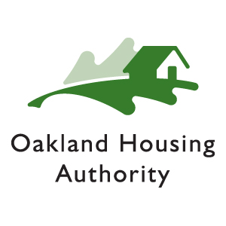

CONTRACT COMPLIANCE & GENERAL SERVICES

QUALIFICATIONS STATEMENT

All questions must be answered, with responses clear and complete. Attach additional pages if needed. This form must be signed by an officer or authorized company staff.

Name of Project: RFP #16-019 – NEPA and CEQA Consultant________________

Company: _____________

Address: ____________

_____________ _______

Telephone: __________________________________________________________________

1. Permanent Main Office address, phone, fax, and website

2. Names and titles of principals

3. Names of authorized signatories

4. If your company is a corporation, answer the following:

    - Date of incorporation:

    - State of incorporation:

    - President’s name:

    - Applicable business and trade licenses:

5. If your company is a partnership, answer the following:

    - Date of licensing:

    - Type of partnership:

    - Name(s) of general partner(s):

6. If your company is individually owned, answer the following:

    - Date of licensing:

ii. Name of owner:

7. Number of years your company has been in business as a Contractor in the State of California for the above type of work?

8. Number of years engaged in business under the company’s present name:

9. List alternative company names and affiliations:

10. List the number of current employees you currently have:

11. List the number of Supervisors and Foreman you currently have:

12. List any type(s) of certification and certification expiration date(s).

13. Indicate the local (city) business license # and date of expiration.

14. Has your company or subsidiary ever defaulted on a contract?

[ ] Yes [ ] No

If yes, what was the name of the contract and what was the reason for default?

15. List all Claims and Suits within the last five (5) years. (If the answers to any of the questions below are yes, please attach details.)

16. Has your company ever refused to sign a contract after award of the bid?

[ ] Yes [ ] No

If yes, what was the name of the contract and reason for refusal?

17. Has your company or subsidiaries or principals ever been debarred from government contracts?

[ ] Yes [ ] No

If yes, please identify party and state the reason.

18. Upon request, will you complete a detailed financial statement and furnish any other information required by the Oakland Housing Authority?

[ ] Yes [ ] No

19. Upon reward of contract, will you add Oakland Housing Authority as an additional insured, provide a 30-day notice of cancellation and be primary to any other insurance carried by OHA for coverage listed under “Insurance Requirements” as listed in the Scope of Work?

[ ] Yes [ ] No

20. Please list any additional information you would like to provide.

The undersigned certifies under oath that the information provided herein is true and sufficiently complete so as not to be misleading and authorizes any person, firm or corporation to furnish any information requested by the Oakland Housing Authority, verifying the declarations included in this Statement of Qualifications.

________________________________ _______________________________
Name Signature

_______________________________ ________________________________
Title Date

